**ONLINE BOOK STORE**

*A project report submitted in partial fulfillment*

*of the requirements for the award of the Degree of*

**Master of Computer Applications (MCA)**

By

**SUBHASIS PADHY**

(Regd No: 121822501009)

*Under the guidance of*

**Prof** **K. Suresh Kumar**

**Assistant Professor**



**Department of Computer Science**

**GITAM Institute of Science**

**GITAM**

**(Deemed to be University)**

**(Estd. u/s 3 of the UGC Act. 1956)**

**Visakhapatnam-530 045, A.P.**

**(2019 – 2020)**

**CERTIFICATE**

This is to certify that the project report titled, “Online Book Store ” is a bonafide record of the project work done by  **SUBHASIS PADHY, Reg.No: 121822501009** during the academic year 2019-2020.

Signature of Signature of Signature of

**Internal Guide External Guide Head of the Department**

**DECLARATION**

I, **SUBHASIS PADHY** declare that this project entitled “**Online Book Store”**,being submitted in partial fulfillment of the requirements for **Masters of Computer Applications** the original work carried out by me and this work has not been submitted towards any other degree or diploma of this in any other universities.

**SUBHASIS PADHY**

**Acknowledgement**

The success and final outcome of this project required a lot of guidance and assistance from many people and I am extremely privileged to have got this all along the completion of my project. All that I have done is only due to such supervision and assistance and I would not forget to thank them.

I respect and thank Prof **K.Vedavati**, Head of Department, for providing me an opportunity to do the project work in GITAM and giving us all support and guidance which made me complete the project duly. I am extremely thankful to her for providing such a nice support and guidance, although he had busy schedule managing the corporate affairs.

I owe my deep gratitude to our project guide and Prof **M.Suresh Kuma** Assistant professor, who took keen interest on our project work and guided us all along, till the completion of our project work by providing all the necessary information for developing a good system.I am heartily thankful for his guidance and suggestions during this project work.

I would not forget to remember faculties of **GITAM**, my family members and my friends for their encouragement and more over for their timely support and guidance till the completion of our project work.

**SUBHASIS PADHY**

**Abstract**

The project titled “ONLINE BOOK STORE" is a web based application.This project is followed the concept of the E-commerce thoroughly. This project is developed to sell the products online of various Books.

This project definitely helps the user to buy anything from the internet because in the ONLINE BOOK STORE you can purchase anything with clicking of the some button of the mouse and pressing some keys of the keyboard & entering your credit card no. in that.

By using this project, the user can save his or her time by purchasing the product which time they are wasting by roaming in the market. From here, they can get most probably all the things they want besides fast moving Entertainment goods. They have various choices in the one Collection.

|  |
| --- |
| **CHAPTER Contents PAGE NO** |
| **1 Introduction**  1.1 Background 07  1.2 Purpose, Scope 08 |
| **2 Requirement Analysis Document**  2.1 Introduction 08  2.2 Functional Requirements 09  2.3 Use Cases 09  2.4 Non Functional Requirements 10  2.5 E-R diagrams 11  2.6 Feasibility Study: 12 |
| **3 Project requirements**  3.1 Software requirement 13  3.2 Sdlc requirements 13  3.3 Hardware Requirements 20  3.4 Interface Requirement 20 |
| **4 System Analysis** 4.1 Database Design 21  4.2 Study of the system 22 |
| **5 Implementation Planning and Details**  5.1 Introduction to Front End 23  5.2 Sample coding 24 |
| **6 Testing**  Testing plan, Strategy, Methods, Test Cases 27 |
| **7 Screen Shots**  Samples Of Forms, Reports and Interfaces 28 |
| **8 Conclusion** 30 |
| **9 References and Bibliography 30** |

INDEX

**1. Introduction**

* 1. **Background**

There are many online book stores like Powell’s, Amazon which were designed using

Html. I want to develop a similar website using HTML, SQL Server.

Online Book store is an online web application where the customer can purchase books

online. Through a web browser the customers can add to the shopping cart and finally purchase using credit card transaction. The user no need of login he /she can directly access the site quickly. They should give the details of their name, contact number in the time of order shipping address.

The user can also give feedback to a book by giving ratings on a score of five. The books

are divided into many categories based on subject Like Software, Database, English,

Architecture etc

This project has the following functionalities:

**1) A Home page with product catalog**

This is the page where the user can access directly. It will display all the main page contents categories and It also includes some special sections like recommended titles, weekly special

books.

**2) Book Description**

If the user would like to know details about a book he can click on the title from where he

will be directed to a Book description page.

**3) User Feedback**

The user can give feedback based on his interest. He can rate it by his/her point of view how they like this organization.

**4) Shopping Cart**

The user can manage a shopping cart which will include all the books he selected. The

user can edit, delete and update his shopping cart. A final shopping cart summary is

displayed which includes all the items the user selected and the final total cost.

**5) Administration**

The Administrator will be provided with special functionalities like

• Add or delete a book category

• Edit a book

• Manage member orders.

• Add or delete a Credit Card type.

* 1. **Purpose and Scope**

The main objective of the project is to create an online book store that allows users to purchase a book based on title, author and subject. The selected books are displayed in a tabular format and the user can order their books online through cash on delivery or payment meathod.

The Scope to create this project has many sources

* Interest to develop a good user friendly website with many online transactions

using a database.

* To increase my knowledge horizon in technologies like .NET, SQL, CSS, HTML.
* To gain good experience in web based application before joining in a full time job.
* To gain expertise php and web base front end development.

We develop this web site “online bookstore.com” which is developed in the hyper text preprocessor (php) as the front end and mysql as back end.

I have put a fair amount of effort in the design of this web site. I have tried my best to satisfy the all requirement in an efficient manner

Requirement Analysis Documen

2.1 Introduction

* OBS should help the customers query whether a book in a stock the user can query the availability of a book either by using the book title or by using the name of author.
* If the book is not currently sold by the bookshop, then the customer is asked to enter the full detail of the book for procurement of the book by the bookshop.
* If a book in stock, the exact number of copies available and the rack number in which the book is located should be displayed.
* If a book not in the stock, the query for the book is used to increment a request field for the book.
* The manager can periodically view the request field of the book arrive at a rough estimate regarding the current demand for different books.
* OBS should maintain the price of various books.
* As soon as customer selects his book for purchase, the sale clerk would enter the ISBN number of the books. OBS should update the stock and generate the sales receipt for the book.
* OBS should allow employees to update inventory whenever new supply arrives. Also upon request by the owner of book shop.
* OBS should generate sales statistics (viz, book name, publisher, ISBN number, number of copies sold and the sales revenue) for any period.
* The sales statistics will help the owner to know the exact business done over any period of time and also determine the inventory level required for various books.

**2.2 Functional Requirements**

* Online book Store prototype is made only for - web based client for Book Buyer.
* The administrative can set data base for book details of the .
* User no need to login in the application he can direct order the book by giving his perfact address and phone number.
* For order any book the user have to give his recent and perfact home location so that we can contact perfactly.

**2.3 Use case**

User and Administrator are the two actors included in the Online Book Store.Fig.2 shows the use case diagram for this website.

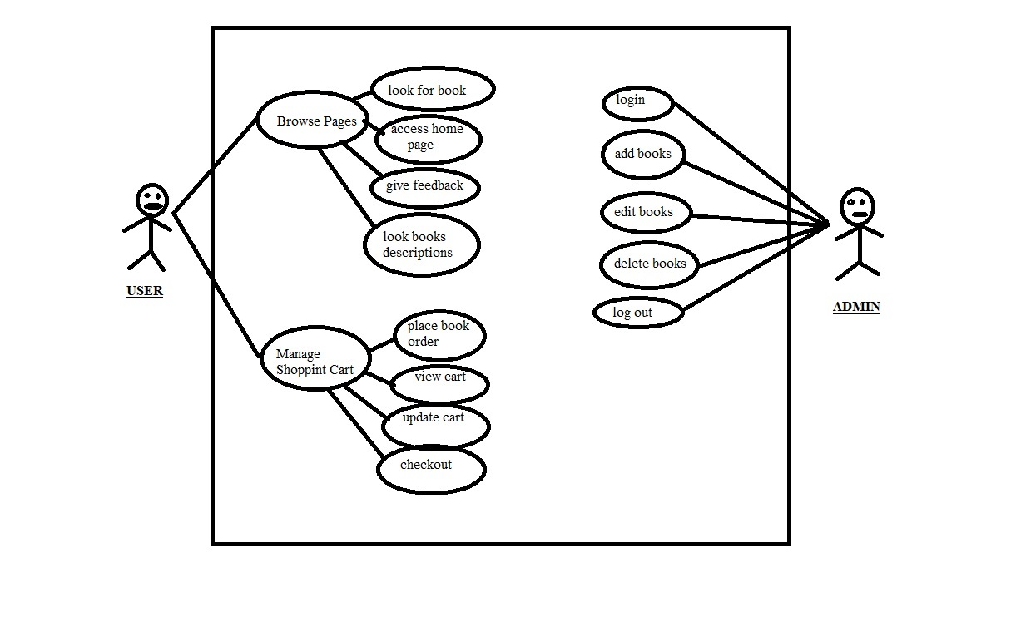

Use Case Diagram

Use Cases: User

Browse pages

1. Look for book:-Here the user serch for the book s he want. So many books are available he/she have to search for which book he want to buy.
2. Access home page:-the user and admin both can use the site home page access. The home page have some contants that may be usefull for user.
3. Give feedback:- the user can give his/her feedback. Feed back is needed for forther development of an web site.
4. Look for book description:- the user can read the book description.

Manage shopping cart

1. Place book order:- If the user wants to purchase a book then he can place an order by selecting the add to shopping cart button and entering the quantity required under the book description.
2. View cart:-If the user wants to view the items he added to the shopping cart then he can click the shopping cart link at the top of the page. He can discard the book from the cart also.
3. Update cart:-If the user wants to change the quantity of a book or change a book then he can update his shopping cart.he can check for the price and he/she can add or remove books from cart.
4. Checkout:-this is the last phase in the checkoutr the user goes for placed order a book and he/she can select money related payment options.

Use Cases: Admin

1. Login:-If the Administrator wants to get access to all the functionalities of Online Book Store he should login using his username and password. If it is a successful login the Administrator will be directed to his menu page. Else if the Administrator enters invalid information he will be asked to check the entered information.
2. Add books:-If the Administrator wants to add a book category then he can insert a book category using his administration rights and the category table will be updated in the database.
3. Edit books:-If the Administrator wants to edit a book description then he can add book description using his administration rights and the category table will be updated in the database.
4. Delete books:-If the Administrator wants delete a book then he can delete a book using his administration rights and the book table will be updated in the database.
5. Logout:-If the Administrator wants to end his session and sign out of the website then he can use the logout option.The Administrator’s account session comes to an end and he should login again if he wants to enter into the website.

**2.4** **Non Functional Requirements**

Portability

The effort required to move the software to a different target platform. The system can easily be moved and executed on new Systems without any difficulties .This will facilitate software portability.

Availability

The program should be flexible and should be available within a mean time and should work in any operating environment.

**2.5 ER-Diagram**

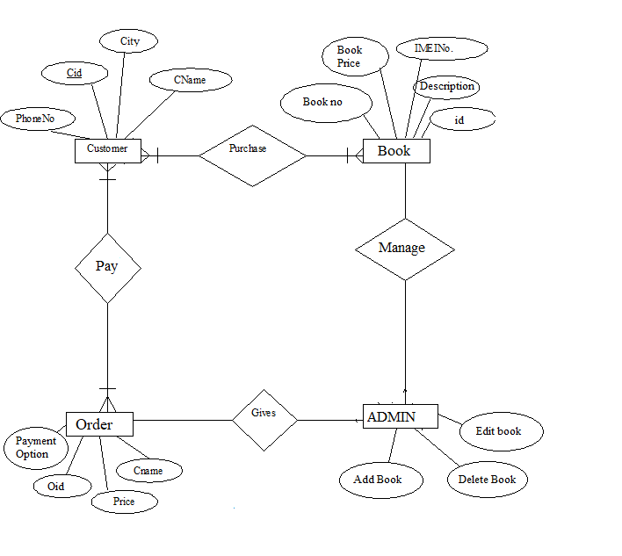

**2.6 Feasibility Study**

Feasibility study is the measure of how beneficial or practical the development of an information system will be to an organization. The Feasibility analysis is a cross life cycle activity and should be continuously performed throughout the system life cycle.Feasibility tests.

Operational feasibility:

By automating the book shop both the customers and employees will feel better than when it was manual. Users will get a very quick service by reducing the manual recordings. Also employees will feel comfortable by reduction of their work. Recording errors will be reduced. Easy to handle a large database. Losing of records will be avoided.Considering all these factors we can conclude that all the users and end users will be satisfied by the system.

Technical feasibility:

For the design and development of the system, several software products have been

accommodated.

· Database design – MySql, or any free DBMS.

· Interface design – HTML,CSS,BOOTSTRAP

· Coding – PHP or any other supported Language.

This software’s have the enough efficiency in producing the system. Therefore the project is

technically feasible.

Schedule feasibility:

The duration of time required for the project has been planned appropriately and it is the same as the duration of time expected by the customer. Therefore the product can be delivered to the customer within the expected time duration, satisfying the customer. Hence the project is feasible in scheduling.

Economic feasibility:

According to the resources available and the project scheduling process it is estimated that the expenses allocated for the software to be developed, by the customer is sufficient enough. Hence the economical factor has been considered feasible.

**Project requirements**

* 1. **Software requirement**

1. My Sql
2. Web Server
3. PHP
4. Dreamweaver
5. Browser
   1. **SDLC Requirements**

SDLC is nothing but Software Development Life Cycle. It is a standard which is used by software industry to develop good software.

Stages in SDLC**:**

* Requirement Gathering
* Analysis
* Designing
* Coding
* Testing
* Maintenance

Requirements Gathering stage:

The requirements gathering process takes as its input the goals identified in the high-level requirements section of the project plan. Each goal will be refined into a set of one or more requirements. These requirements define the major functions of the intended application, defineoperational data areas and reference data areas, and define the initial data entities. Major functions include critical processes to be managed, as well as mission critical inputs, outputs and reports. A user class hierarchy is developed and associated with these major functions, data areas, and data entities. Each of these definitions is termed a Requirement. Requirements are identified by unique requirement identifiers and, at minimum, contain a requirement title and

textual description.

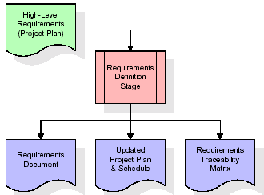

These requirements are fully described in the primary deliverables for this stage: the Requirements Document and the Requirements Traceability Matrix (RTM). The requirements document contains complete descriptions of each requirement, including diagrams and references to external documents as necessary. Note that detailed listings of database tables and fields are *not* included in the requirements document. The title of each requirement is also placed into the first version of the RTM, along with the title of each goal from the project plan. The purpose of the RTM is to show that the product components developed during each stage of the software development lifecycle are formally connected to the components developed in prior stages.

In the requirements stage, the RTM consists of a list of high-level requirements, or goals, by title, with a listing of associated requirements for each goal, listed by requirement title. In this hierarchical listing, the RTM shows that each requirement developed during this stage is formally linked to a specific product goal. In this format, each requirement can be traced to a specific product goal, hence the term requirements traceability.

The outputs of the requirements definition stage include the requirements document, the RTM, and an updated project plan.

* Feasibility study is all about identification of problems in a project.
* No. of staff required to handle a project is represented as Team Formation, in this case only modules are individual tasks will be assigned to employees who are working for that project.
* Project Specifications are all about representing of various possible inputs submitting to the server and corresponding outputs along with reports maintained by administrator

Analysis Stage:

The planning stage establishes a bird's eye view of the intended software product, and uses this to establish the basic project structure, evaluate feasibility and risks associated with the project, and describe appropriate management and technical approaches.

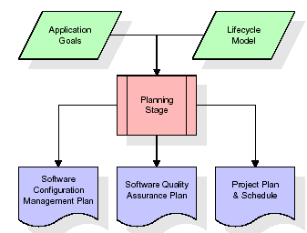

The most critical section of the project plan is a listing of high-level product requirements, also referred to as goals. All of the software product requirements to be developed during the requirements definition stage flow from one or more of these goals. The minimum information for each goal consists of a title and textual description, although additional information and references to external documents may be included. The outputs of the project planning stage are the configuration management plan, the quality assurance plan, and the project plan and schedule, with a detailed listing of scheduled activities for the upcoming Requirements stage, and high level estimates of effort for the out stages.

Designing Stage:

The design stage takes as its initial input the requirements identified in the approved requirements document. For each requirement, a set of one or more design elements will be produced as a result of interviews, workshops, and/or prototype efforts. Design elements describe the desired software features in detail, and generally include functional hierarchy diagrams, screen layout diagrams, tables of business rules, business process diagrams, pseudo code, and a complete entity-relationship diagram with a full data dictionary. These design elements are intended to describe the software in sufficient detail that skilled programmers may develop the software with minimal additional input.

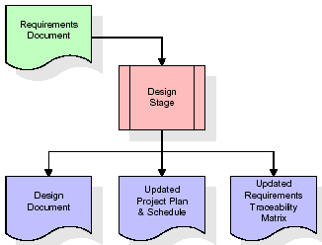

When the design document is finalized and accepted, the RTM is updated to show that each design element is formally associated with a specific requirement. The outputs of the design stage are the design document, an updated RTM, and an updated project plan.

Development (Coding) Stage**:**

The development stage takes as its primary input the design elements described in the approved design document. For each design element, a set of one or more software artifacts will be produced. Software artifacts include but are not limited to menus, dialogs, data management forms, data reporting formats, and specialized procedures and functions. Appropriate test cases will be developed for each set of functionally related software artifacts, and an online help system will be developed to guide users in their interactions with the software.

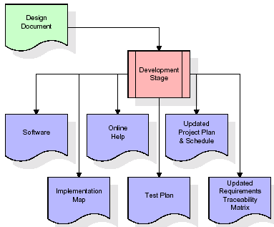

The RTM will be updated to show that each developed artifact is linked to a specific design element, and that each developed artifact has one or more corresponding test case items. At this point, the RTM is in its final configuration. The outputs of the development stage include a fully functional set of software that satisfies the requirements and design elements previously documented, an online help system that describes the operation of the software, an implementation map that identifies the primary code entry points for all major system functions, a test plan that describes the test cases to be used to validate the correctness and completeness of the software, an updated RTM, and an updated project plan.

Integration & Test Stage**:**

During the integration and test stage, the software artifacts, online help, and test data are migrated from the development environment to a separate test environment. At this point, all test cases are run to verify the correctness and completeness of the software. Successful execution of the test suite confirms a robust and complete migration capability. During this stage, reference data is finalized for production use and production users are identified and linked to their appropriate roles. The final reference data (or links to reference data source files) and production user list are compiled into the Production Initiation Plan.

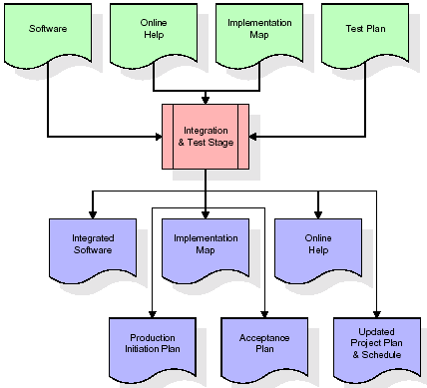

The outputs of the integration and test stage include an integrated set of software, an online help system, an implementation map, a production initiation plan that describes reference data and production users, an acceptance plan which contains the final suite of test cases, and an updated project plan.

Installation & Acceptance Test**:**

During the installation and acceptance stage, the software artifacts, online help, and initial production data are loaded onto the production server. At this point, all test cases are run to verify the correctness and completeness of the software. Successful execution of the test suite is a prerequisite to acceptance of the software by the customer.

After customer personnel have verified that the initial production data load is correct and the test suite has been executed with satisfactory results, the customer formally accepts the delivery of the software.

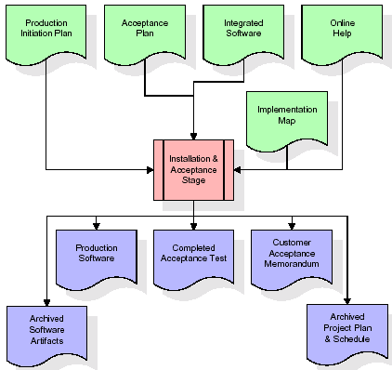

The primary outputs of the installation and acceptance stage include a production application, a completed acceptance test suite, and a memorandum of customer acceptance of the software. Finally, the PDR enters the last of the actual labor data into the project schedule and locks the project as a permanent project record. At this point the PDR "locks" the project by archiving all software items, the implementation map, the source code, and the documentation for future reference.

Maintenance**:**

Outer rectangle represents maintenance of a project, Maintenance team will start with requirement study, understanding of documentation later employees will be assigned work and they will undergo training on that particular assigned category. For this life cycle there is no end, it will be continued so on like an umbrella (no ending point to umbrella sticks).

* 1. **Hardware Requirement**

Processor : Any Processor above 500 MHz.

Hard Disk : 10 GB and above.

Ram : 128 MB and above.

* 1. **Interface Requirement**

User Interfaces

The system users are:-

* The book shop management as the system administrators.
* Book shop cashiers as the normal users.

System administrators

The administrator logs on to the system by inserting administrator user name and password. Administrator can do any transaction as well as editing all details inside the database such as adding, editing and deleting a new Book.

System users

System users are the ones who at the cashier and do transactions with customers. The users have to enter the user name and password and click on ‘Login’ button. If user makes any mistake the system will ask for the correct username and password until he enters the correct one. When the user wants to do any transaction user has to click on the menu icon on the main menu. Then the transaction window will open. User has to enter the Book No and press enter. Then user has to select the transaction type and the quantity. Then click on the update button. Then the system will automatically update the database according to the transaction type. Hardware Interfaces.

The Book Shop System is having the following hardware:

* Book shop main computer
* Other pc’s

Software Interfaces

* System will interact with the system database to record all transaction data.

Performance Requirements:

* The response time for menu changes will be not more than 3 seconds.
* The time for search for a book will not more than 3 seconds.
* The time to print the stock valuation will not be more than 3 seconds.
* The time taken to update the database or get information from the database will not be more than 2 seconds.
* The time taken to prompt message boxes will not more than 2 seconds.

Design Constraints**:**

* The system is based on menu driven interfaces. Menu selection will be done by using the mouse and the key board keys.
* Confirmation messages on taken actions, input acceptance and error conditions will be displayed after each input.
* Error messages will be displayed at the time of detection of input errors and the system errors.

Maintainability:

To make ease of maintain the system to the Book shop administrators the user

manual and the system manual is provided at the delivery. Each module is designed

independently so that at any change of a request can be modified easily.

Security:

Only the administrators have the authority to edit details in Users and Items tables. No one can enter the system without a username and a password. Normal system users cannot access the Administrators login. All deleting actions are notified by a message box asking to confirm deletion.

**System Analysis**

**4.1Database design**

The database contains following tables

Admin table

|  |  |  |
| --- | --- | --- |
| Field Name | Data Type | Description |
| Name | Varchar(20) | Primary Key |
| Pass | Varchar(40) | Primary Key |

Books Table

|  |  |  |
| --- | --- | --- |
| Field Name | Data Type | Description |
| BookIsbn | Varchar(20) | Primary Key |
| Book_Title | Varchar(60) |  |
| Book_Author | Varchar(60) |  |
| Book_Image | Varchar(40) |  |
| Book_Descr | Text |  |
| Book_Price | Decimal(6,2) |  |
| Publisher | Var(50) |  |

Customer

|  |  |  |
| --- | --- | --- |
| Field Name | Data Type | Description |
| Customerid | Int(10) |  |
| Name | Varchar(60) |  |
| Address | Varchar(80) |  |
| City | Varchar(30) |  |
| Zip_code | Int(6) |  |
| Country | Varchar(60) |  |

Oredered item

|  |  |  |
| --- | --- | --- |
| Field Name | Data Type | Description |
| Ordered id | int(10) |  |
| Book_isbn | Varchar(20) |  |
| Item_Price | Decimal(6,2) |  |
| Quantity | Tinyint(3) |  |

Order

|  |  |  |
| --- | --- | --- |
| Field Name | Data Type | Description |
| Orderid | Int(10) | Primary Key |
| Customerid | Int(10) |  |
| Amount | Decimal(6,2) |  |
| Date | timestamp |  |
| Ship_name | Char(60) |  |
| Ship_address | Char(80) |  |
| Ship_city | Char(30) |  |
| Ship_zip_code | Int(6) |  |
| Ship_country | Char(20) |  |

**4.1 Study of the system**

To provide flexibility to the users, the interfaces have been developed that are accessible through a browser. The GUI’S at the top level have been categorized as

* Administrative user interface
* The operational or generic user interface

The ‘administrative user interface’ concentrates on the consistent information that is practically, part of the organizational activities and which needs proper authentication for the data collection. These interfaces help the administrators with all the transactional states like Data insertion, Data deletion and Date updation along with the extensive data search capabilities.

The ‘operational or generic user interface’ helps the end users of the system in transactions through the existing data and required services. The operational user interface also helps the ordinary users in managing their own information in a customized manner as per the included flexibilities

**Implementation Planning and Details**

**5.1 Introduction to Front End**

In the world of software development, what’s built falls into two categories: everything that’s seen by the user and the processes happening in the background. What we see and interact with as the visitors of a website, or as the end user of a mobile app, is considered front-end technology. All the behind-the-scenes activity that delivers the data and the speed with which that data is delivered falls into back end technology.Basically the web development projects are made with HTML,CSS,BOOTSTRAP.

The front end stack is made up of many different languages and libraries. While these vary from application to application, there are only a few generic languages understood by all web browsers. These three main front-end coding languages are HTML, CSS and JavaScript.

Together, they create the underlying scaffolding that web browsers use to render the web pages that we interact with every day. All other libraries and front-end engineering are built upon these three main languages, which makes them must-have skills for any front-end developer.

HTML:

It is the first layer of any website and creates the code version of a wireframe on a webpage. These wireframes exist for the styles in CSS and all the bells and whistles in JavaScript.

The letters in HTML stand for Hypertext Markup Language. The markup piece of the name is the most important to remember, as markups are the proper name for HTML elements, which are also called HTML tags. HTML as a whole is the markup that creates the basic elements we view on a website.

However, it’s important to remember that HTML isn’t particularly intelligent. It doesn’t make decisions or capture information on its own. It simply renders the scaffolding of the web pages.

CSS:

Cascading Style Sheets, or CSS, is what gives our HTML visual appeal and draws in the user. To put it simply, style sheets dictate the presentation of HTML elements on a page.CSS is what makes everything not look like a white background with a bunch of Times New Roman texts and blue hyperlinks. Have you ever tried to load Amazon on a bad day and see nothing but a white page with a huge list of black texts, some blue links and nothing else? That’s Amazon loading without styles. Styles are what transition beautiful designs onto a site.

A new trend with styling is to use what is called a CSS pre-processor. These include Less, Sass and stylists. Pre-processors are scripting languages that compile to CSS for the browser and are very popular as they expedite the development process. They accommodate some programming logic.

CSS pre-processors consolidate styling through “usability” and scale easily for use with large websites. Most front-end engineers of all levels have experience with pre-processors due to their power and flexibility to suit all scenarios, from building small single-page websites to enterprise applications such as Groupon or NBCUniversal.

**5.2 Sample Coading**

<?php

function db_connect(){

$conn = mysqli_connect("localhost", "root", "", "www_project");

if(!$conn){

echo "Can't connect database " . mysqli_connect_error($conn);

exit;

}

return $conn;

}

function select4LatestBook($conn){

$row = array();

$query = "SELECT book_isbn, book_image FROM books ORDER BY book_isbn DESC";

$result = mysqli_query($conn, $query);

if(!$result){

echo "Can't retrieve data " . mysqli_error($conn);

exit;

}

for($i = 0; $i < 4; $i++){

array_push($row, mysqli_fetch_assoc($result));

}

return $row;

}

function getBookByIsbn($conn, $isbn){

$query = "SELECT book_title, book_author, book_price FROM books WHERE book_isbn = '$isbn'";

$result = mysqli_query($conn, $query);

if(!$result){

echo "Can't retrieve data " . mysqli_error($conn);

exit;

}

return $result;

}

function getOrderId($conn, $customerid){

$query = "SELECT orderid FROM orders WHERE customerid = '$customerid'";

$result = mysqli_query($conn, $query);

if(!$result){

echo "retrieve data failed!" . mysqli_error($conn);

exit;

}

$row = mysqli_fetch_assoc($result);

return $row['orderid'];

}

function insertIntoOrder($conn, $customerid, $total_price, $date, $ship_name, $ship_address, $ship_city, $ship_zip_code, $ship_country){

$query = "INSERT INTO orders VALUES

('', '" . $customerid . "', '" . $total_price . "', '" . $date . "', '" . $ship_name . "', '" . $ship_address . "', '" . $ship_city . "', '" . $ship_zip_code . "', '" . $ship_country . "')";

$result = mysqli_query($conn, $query);

if(!$result){

echo "Insert orders failed " . mysqli_error($conn);

exit;

}

}

function getbookprice($isbn){

$conn = db_connect();

$query = "SELECT book_price FROM books WHERE book_isbn = '$isbn'";

$result = mysqli_query($conn, $query);

if(!$result){

echo "get book price failed! " . mysqli_error($conn);

exit;

}

$row = mysqli_fetch_assoc($result);

return $row['book_price'];

}

function getCustomerId($name, $address, $city, $zip_code, $country){

$conn = db_connect();

$query = "SELECT customerid from customers WHERE

name = '$name' AND

address= '$address' AND

city = '$city' AND

zip_code = '$zip_code' AND

country = '$country'";

$result = mysqli_query($conn, $query);

// if there is customer in db, take it out

if($result){

$row = mysqli_fetch_assoc($result);

return $row['customerid'];

} else {

return null;

}

}

function setCustomerId($name, $address, $city, $zip_code, $country){

$conn = db_connect();

$query = "INSERT INTO customers VALUES

('', '" . $name . "', '" . $address . "', '" . $city . "', '" . $zip_code . "', '" . $country . "')";

$result = mysqli_query($conn, $query);

if(!$result){

echo "insert false !" . mysqli_error($conn);

exit;

}

$customerid = mysqli_insert_id($conn);

return $customerid;

}

function getPubName($conn, $pubid){

$query = "SELECT publisher_name FROM publisher WHERE publisherid = '$pubid'";

$result = mysqli_query($conn, $query);

if(!$result){

echo "Can't retrieve data " . mysqli_error($conn);

exit;

}

if(mysqli_num_rows($result) == 0){

echo "Empty books ! Something wrong! check again";

exit;

}

$row = mysqli_fetch_assoc($result);

return $row['publisher_name'];

}

function getAll($conn){

$query = "SELECT * from books ORDER BY book_isbn DESC";

$result = mysqli_query($conn, $query);

if(!$result){

echo "Can't retrieve data " . mysqli_error($conn);

exit;

}

return $result;

}

?>

**Testing**

Introduction

The goal of this document is to develop a test plan for the Online Book Store

design system. This document defines all the procedures and activities required to

prepare for testing of the functionalities of the system which are specified in Vision

document. The objectives of the test plan are to define the activities to perform testing, define the test deliverables documents and to identify the various risks and contingencies involved in testing.

Features to be tested

The following list describes the features to be tested:

USER:

*  Add To Cart
* Edit Cart
* Purchase

ADMIN:

* Create and Delete book from Category
* Delete a Category
* Add a book
* Edit a book

Unit testing

Unit testing is a method of testing that verifies the individual units of source code are working properly. The goal of unit testing is to isolate each part of the program and show that the individual parts are correct. The NUnit a testing tool for C# will be used for unit testing.

Load testing

* Load testing is the process of creating demand on a system or device and measuring
* its response. It generally refers to the practice of modeling the expected usage of a
* software program by simulating multiple users accessing the program concurrently. As
* such, this testing is most relevant for multi-user systems; often one built using a
* client/server model, such as web servers

System Testing

Once the entire system has been built then it has to be tested against the Software Requirement Specification and System Specification to check if it delivers the features required. System testing can involve a number of specialist types of test to see if all the functional and non-functional requirements have been met.

Performance Testing

The system should meet the performance requirements as mentioned in the Vision document. The performance will be evaluated based on the response time of the GUI and the database commands. Using JMETER tool performance testing will be done.

Manual Testing

Manual Testing will be done to ensure the correctness of various parts of the code using test cases generated by the tester

Pass/fail criteria

The system should satisfy all the functional requirements, in the Vision document.

Each feature to be tested will be evaluated against its requirement as stated in the Vision Document. The pass or fail of a test depends on whether the system meets with all the particular post conditions.Test cases executed on the Online Book Store will pass if they meet the specific requirements as mentioned in the Vision Document.

Performance Testing

The system should meet the performance requirements as mentioned in the Vision

document. The performance will be evaluated based on the response time of the GUI and the database commands. Using JMETER tool performance testing will be done. Apache server is a 100% pure Java desktop application designed to load test functional behavior and measure performance*.* Originally designed to test webapplications, it is now a general tool for testing client/server applications like database servers, FTP servers and others. It lets you test your applications under different work loads, and graphically represent the application's behavior.

I have tested the performance of three different pages of my Online Book Store

Website as mentioned in the Test Plan document during Phase-2.

Pages Tested

* Home Page
* Books Page
* Shopping Cart Page
* Checkout page

The Performance testing has been done using a sample of 8 threads which are

generated with a loop of 100.

**Screen Shots**

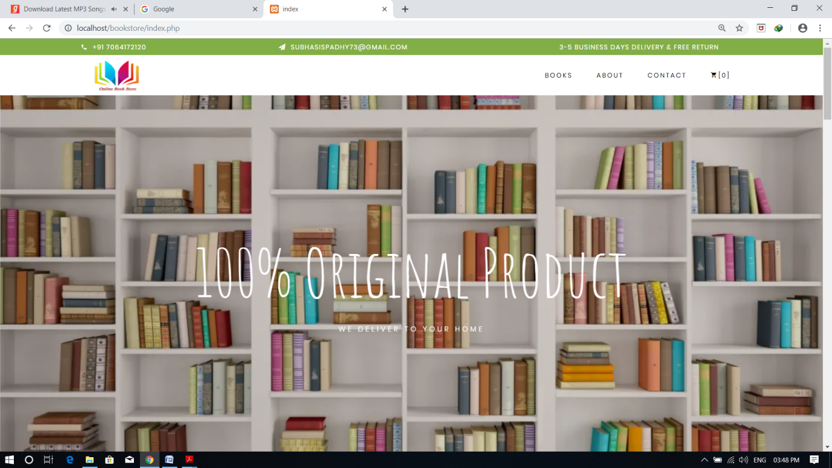

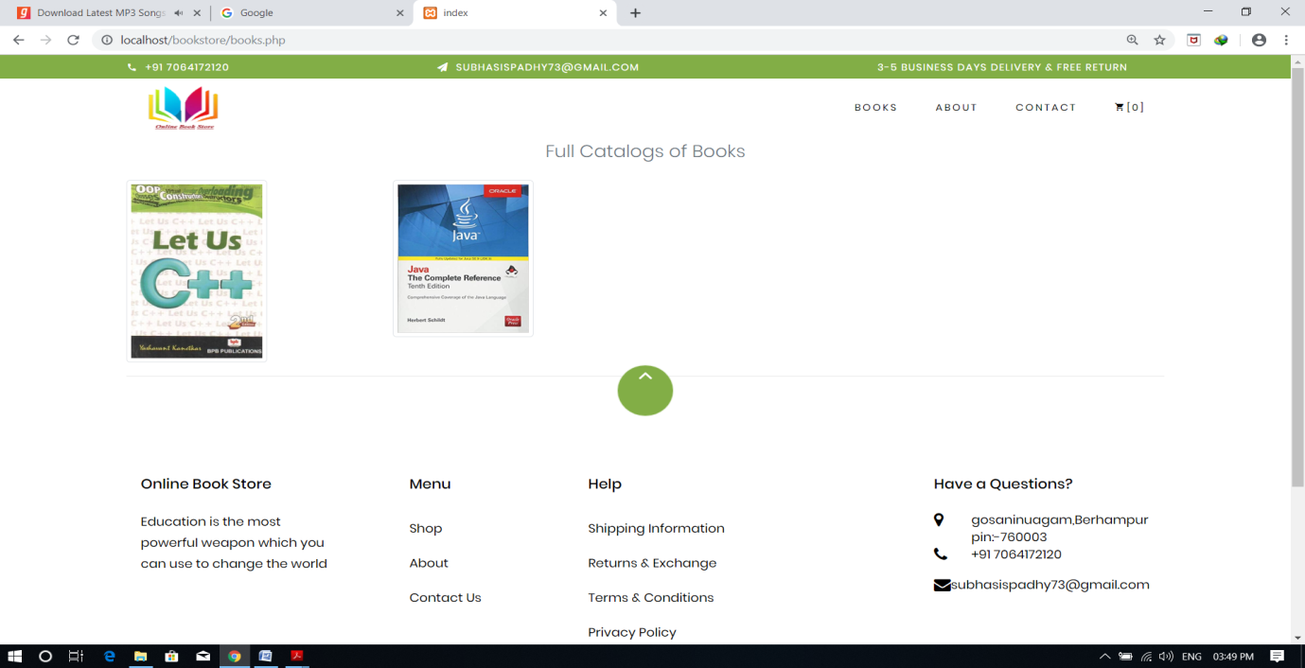

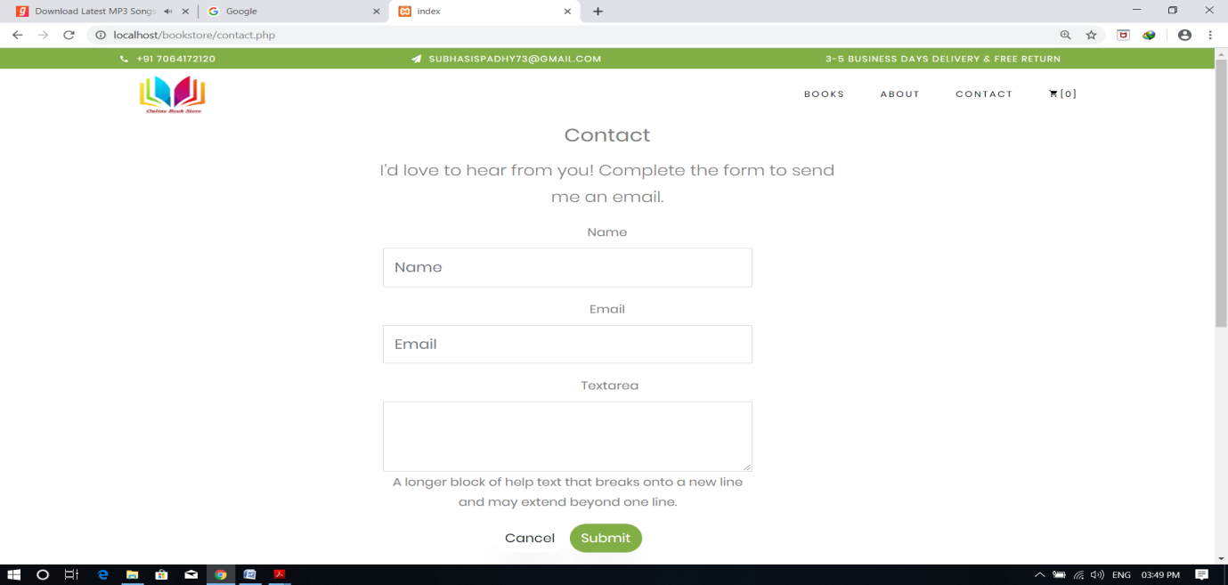

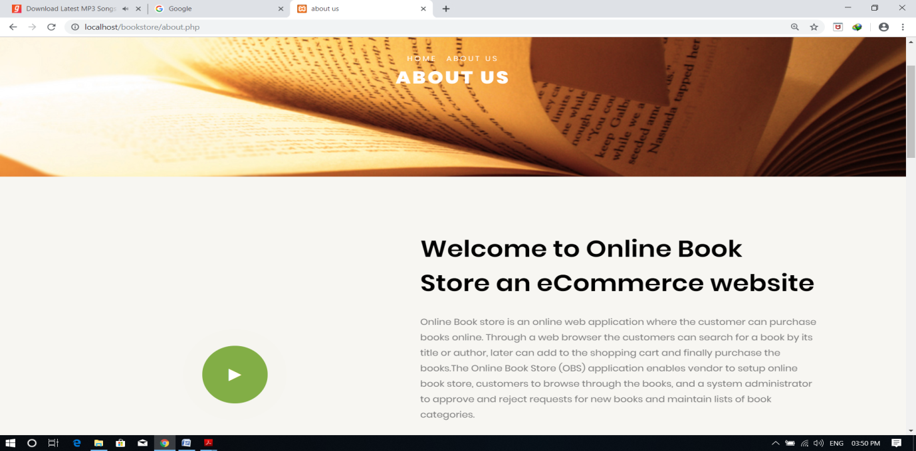

**Conclusion**

This online book store system is an attempt to overcome the present inefficient and time consuming process of locating, reserving and purchasing quality reading materials available in the store. Currently, clients have to go through a time consuming process to Performa fore mentioned tasks which cause waste of labor and firms resources. Through our online book store system, we provide an easy way of searching, reserving and purchasing of books. User data are validated and checked for authenticity with the data stored in the system database.

All the newly coined processes will address time consuming, ineffective and inefficient areas ofthe existing system which has being wasting a lot of firms resources such as, labor, electricity,equipment, products and services, while discouraging customers to make purchases and repelling clients from the book store.Proposed system will support both clients and the store in many areas. It’s worth analyzing andidentifying the benefits as it would directly influence the productivity of the store.

Customer satisfaction plays the most vital role in any form of product and service rendering store as the existence of any firm solely depends on its customer-base. Therefore, every system should facilitate the customer satisfaction up to a certain extent which is feasible from the companyperspective.The aforementioned facts ensure customer satisfaction to a greater extent benefiting the store in:

* Retaining current customers
* Tempting current customers to attract their friends to the store _ Attracting new customers
* Enhancing the customer faith on the firm due to secure transaction techniques while

temping customers to make more online purchases

* Identifying profitable customers
* Identifying different categories of customers
* Making necessary alterations and plans to address broader range of customers
* Identifying key areas of the inventory which need to be maintained at a healthy stocklimit
* Analyzing trends to make more effective management decisions and development of new strategies to increase profit

These particulars will make sure the broadening the customer base of the store which will have good impact on the sales and revenue of the store.

Employee satisfaction also plays an influential role in healthy revenue levels of a firm. Due to

the proposed system, employees will have to handle minimum amount of workload than that ofthe existing system which will help the employees to provide optimal service to the firm while maintaining healthy physical and mental levels.

**References and Bibliography**

* HTML –> <https://www.w3schools.com/html/>
* CSS -> <https://www.w3schools.com/css/default.asp>
* BOOTSTRAP-> <https://www.w3schools.com/bootstrap4/default.asp>
* PHP-> <https://www.w3schools.com/php/default.asp>
* Webdevelopment books-> Learning Web Design

Book by Jennifer Niederst Robbins

* Php mysql book-> Learning PHP, MySQL, JavaScript, CSS & HTML5

Book by Robin Nixon